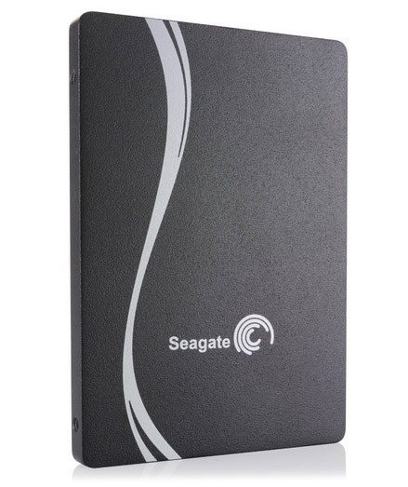

Seagate 600 SSD

The company has actually released two SSDs—the 600 and the 600 Pro—and this review focuses on the consumer-oriented 600 flavor. Both use Link_A_ Media's LM87800 controller. That's not a common option, though Corsair uses it in their Neutron series of drives as well. Documentation on the controller is scarce, but we know it's an eight-channel design that supports all of the modern Flash types and can address up to 1TB of NAND. Seagate's product specs for the 600 list an annualized failure rate of 0.58% and an unrecoverable read error likelihood of one to 10E16. That's actually substantially better than the company's mobile drives, which list error rates of 10E14, though it should be noted that such measurements have been criticized as generally unrealistic.

If you store all your data in the cloud, it might be hard to fathom an external hard drive doing double duty as a status symbol. That's exactly what the sleek, wildly fast, and eye-wateringly expensive Samsung Portable SSD X5 is, though. Following in the footsteps of both Samsung's own flagship external drives like the Portable SSD T5 and design-forward works of hard drive art from LaCie and others, the X5 offers copious amounts of solid-state storage at extreme speeds, thanks to its use of the cutting-edge Thunderbolt 3 and PCI Express NVMe interfaces. It would make a killer gift for Mac-bound video editors who shoot in 4K or photographers who work in RAW, but it's overkill for pretty much anyone else. If you store all your data in the cloud, it might be hard to fathom an external hard drive doing double duty as a status symbol. That's exactly what the sleek, wildly fast, and eye-wateringly expensive Samsung Portable SSD X5 is, though. Following in the footsteps of both Samsung's own flagship external drives like the Portable, thanks to its use of the cutting-edge Thunderbolt 3 and PCI Express NVMe interfaces. It would make a killer gift for Mac-bound video editors who shoot in 4K or photographers who work in RAW, but it's overkill for pretty much anyone else.

SPEC DATA:

Type:
Internal

Storage Capacity (as Tested):
480 GB

Rotation Speed:
SSD

Ports:
None

